**Online Shopping Application: Requirements**

**Customer Login Interface**

Login interface is the gateway for the user to make any transactions like buy product, add items to cart, payment details, etc.

This should consist of the following requirements.

1. Should have two mandatory fields namely, “User Name and “Password”.
2. Should also have two options for “New User’s Registration” which should redirect to “Registration” page and a “Forgot Password” option in case a user forgets the password.

**Sample Login Page**

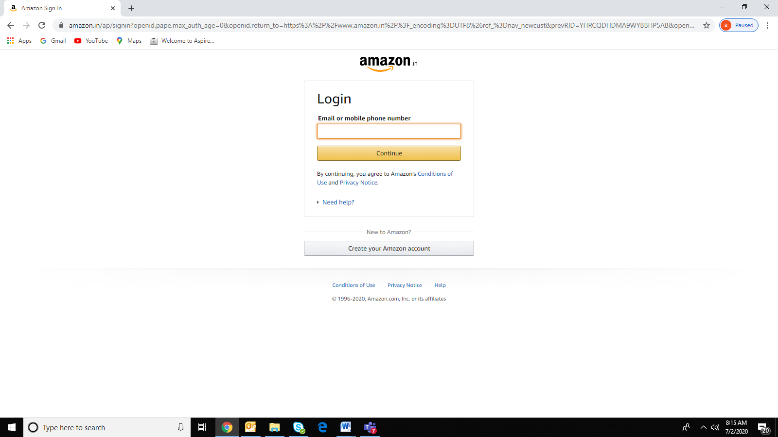

1. If the username and password is correct, it should navigate to product page.
   1. If the username is empty, it should display the message to enter the username. The username should not be empty.
   2. If the user enters invalid username, it should display the error message as invalid username.

**Sample Username Validation Page**

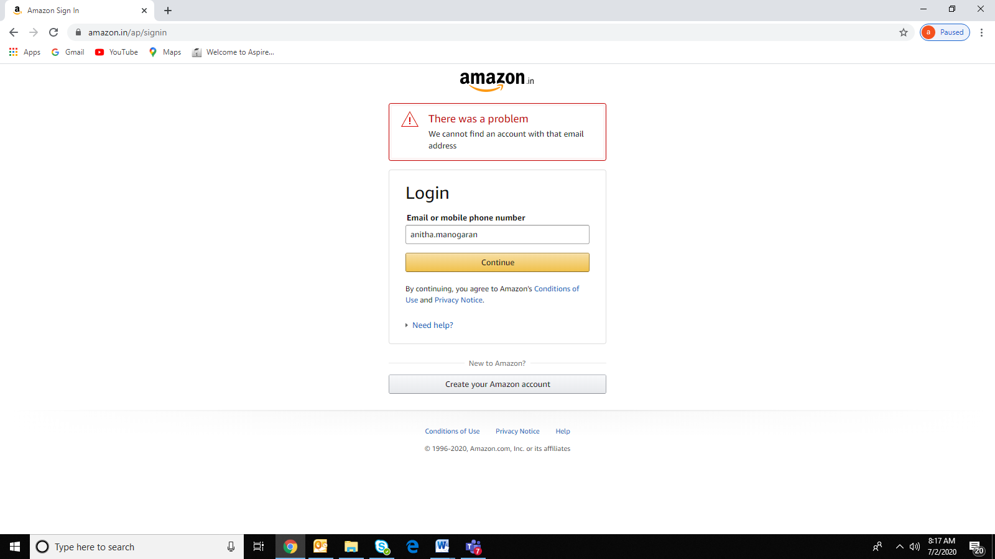

* 1. After entering a valid username, the user should be allowed to enter password.
  2. If the password is empty, it should display the message to enter password. The password should not be empty.
  3. The password should be in encrypted form.
  4. If the user enters invalid password, it should display the error message as invalid password.

1. The user should be allowed three attempts to login.
2. The account should be locked at the fourth attempt. The user should be provided with forgot password option (mobile number/email id) to retrieve their password.
3. If the person is a new user, then the login page should be provided with option for sign up, which navigates to new user registration page.

**New User Registration**

When a user first visits the store to buy product, the application should not overwhelm them with different forms asking for personal information. The user should be allowed to browse the app as a guest and in case they are interested in buying goods/services, then ask them to open an account with the simple registration form.

The new user should be provided with sign up page, where they have to fill with three mandatory fields, username, mobile number and password. The email field is optional.

User should be keep informed about any mistakes on data format or other constrains by validation notes and error messages.

**Sample Registration Form**

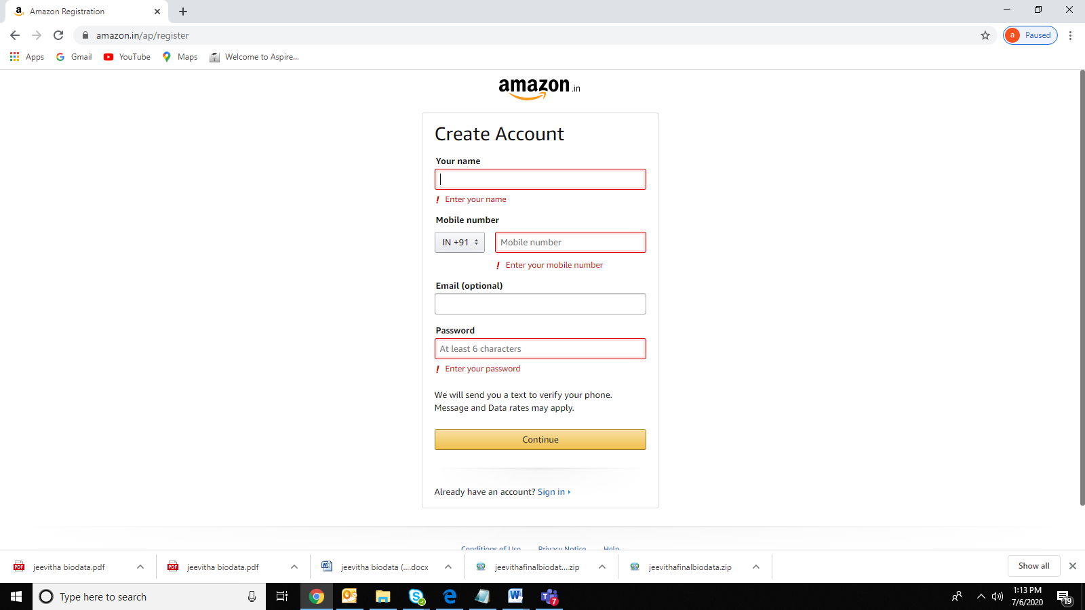

1. Username validation should
   1. Not be empty.
   2. Be a unique name, which consists of only characters. No digits or special symbols are allowed.
   3. Be length of minimum eight characters.

**Sample Username Validation**

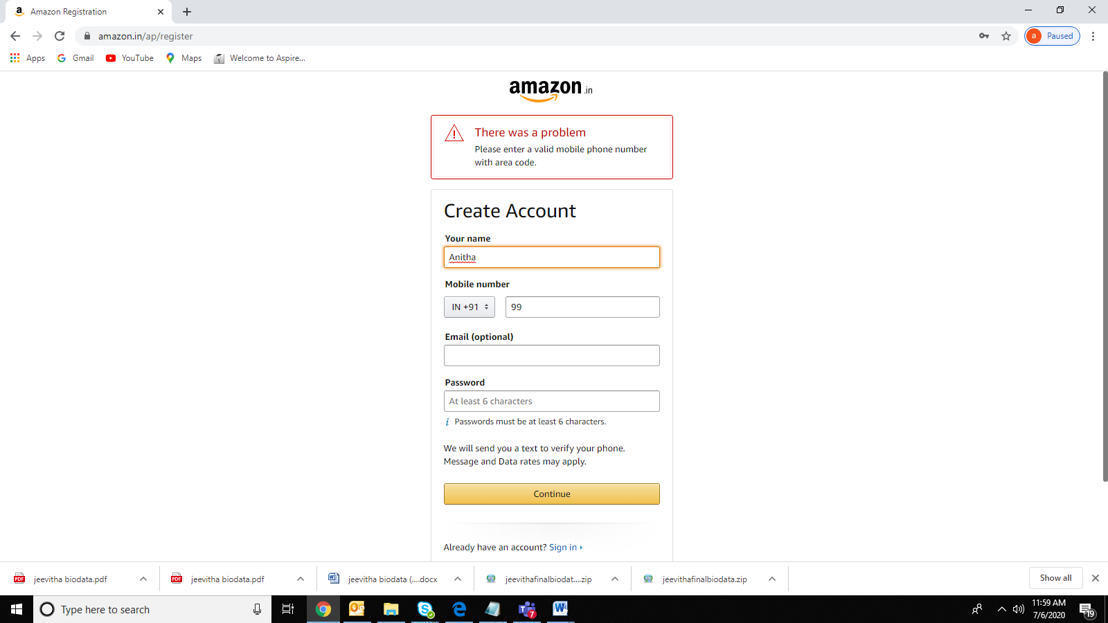

1. The password should
   1. Not be empty
   2. Be at least one character, one digit and one special character.
   3. Be length of minimum six.
2. The mobile number should
   1. Not be empty
   2. Consists of ten digits
   3. Start with digit from Six to Nine
   4. Contain country code
3. The email should be “[firstname.lastname@domain](mailto:firstname.lastname@domain) name.top-level domain name” format.

For e.g. ([jaya.ethiraj@aspiresys.com](mailto:jaya.ethiraj@aspiresys.com))

1. All these validations are required for both console and as well web applications.
2. The username, password, mobile number and email id should be given in label control and the input value should be entered in the textbox control, in case of web application.
3. The mandatory fields should be indicated with * symbol. A note should be given below defining that * symbol indicates the mandatory fields.

If everything is entered correctly, the new user should be created and redirected to login page.

**Edit Personal Data**

If any member wants to change his personal information he should enter his profile and edit the personal details.

**Home Page**

When we are planning to create a shopping app like Amazon for the business, then it should be absolutely clear with [essential features that need to be include](https://www.gurutechnolabs.com/ecommerce-app-development/#ecommerce-mobile-app-features)d like search product, product list, easy navigation, cart, faster checkout, registration/login, payment gateways, etc.

The user should be provided with home page access without signing in until they are interested to buy products.

**Sample Home Page**

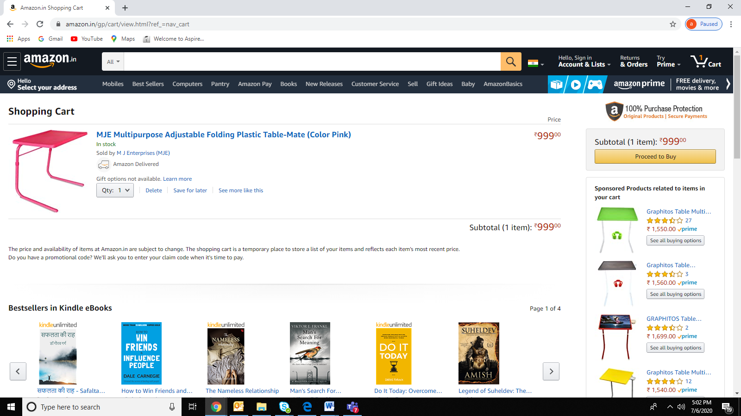

The home page consists should of essential features

1. SearchProduct
2. ProductList
3. Cart
4. Delivery Address
5. PaymentDetails
6. SearchProduct

The user should

* 1. Be provided with an option to search product.
  2. Enter the type / specifications of item he is looking for and search for an item.
  3. Be provided with advanced search for more options. For eg: the user should filter the results basing on various aspects such as size, color, material, brand etc. and also they should sort the product display according to their wish(relevance, price in ascending or descending, popularity).

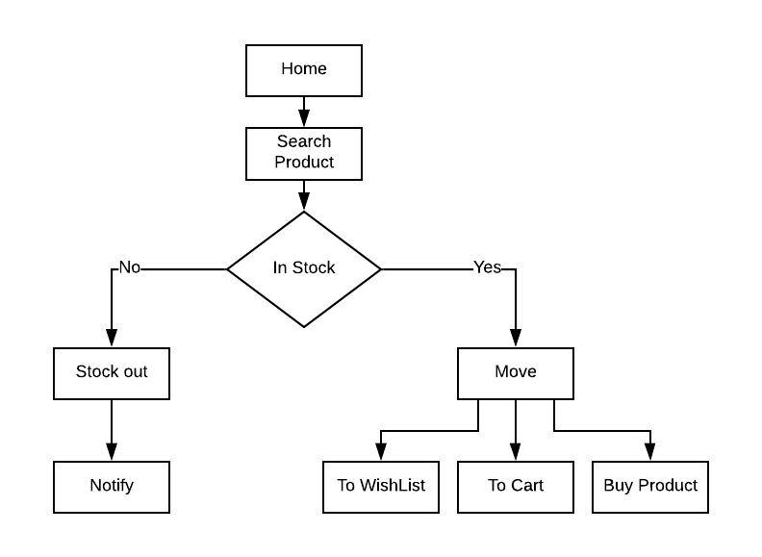

1. Product List

The user should be provided with

* 1. The product list with short description.
  2. The products should be displayed under various categories.
  3. The easy navigation for the product list.

1. Cart
   1. Cart should be a space for the user where they should store the items he/she wishes to buy.
   2. The user should be able to remove items from cart prior to checkout.
   3. They should shortlist their favorite item as a save for later/wish list for future reference.
   4. Once the user decides to buy the items in cart, the user is directed to sign in page and then to delivery address page prior to make payment.

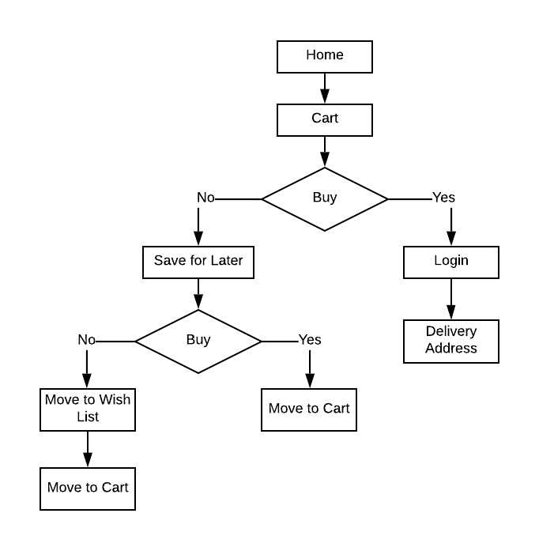

1. Delivery Address

The user should

* 1. Enter the delivery address.
  2. Have the option for change delivery address
  3. Be provided with options for sending invoice bill

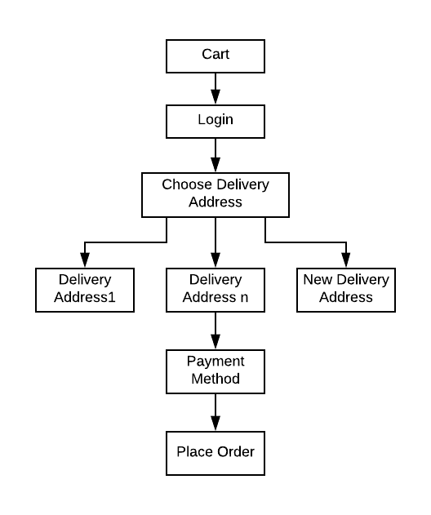

* 1. The address field should consists of
     1. Full Name

Proper validation should be given

* Should not be empty
* Only characters are allowed
* Digits or special symbols are not allowed
  + 1. Mobile Number
* Should not be empty
* A valid ten digit number
* Starts with six to nine
* Provided with country code
  + 1. Pincode
* Should not be empty
* Digits should be allowed
* Length is of six, in case of country, India
  + 1. Flat/HouseNo./Building/Company/Apartment
* Should not be empty
* The user should provide a valid single line address
* A combination of digits, characters and symbols
  + 1. Area/Colony/Street/Sector/Village
* Is Optional
* Only characters are allowed
* Digits or special symbols are not allowed
  + 1. Landmark
* Is Optional. e.g. near Post Office
  + 1. Town/City
* Should not be empty
* A valid town/city name is allowed
* Only characters are allowed
* Digits, special symbols are not allowed
  + 1. State
* Is Optional
* A valid state name should be given
* Only characters are allowed
* Digits, special symbols are not allowed

All the fields should be validated.

Sample Delivery Address Validation

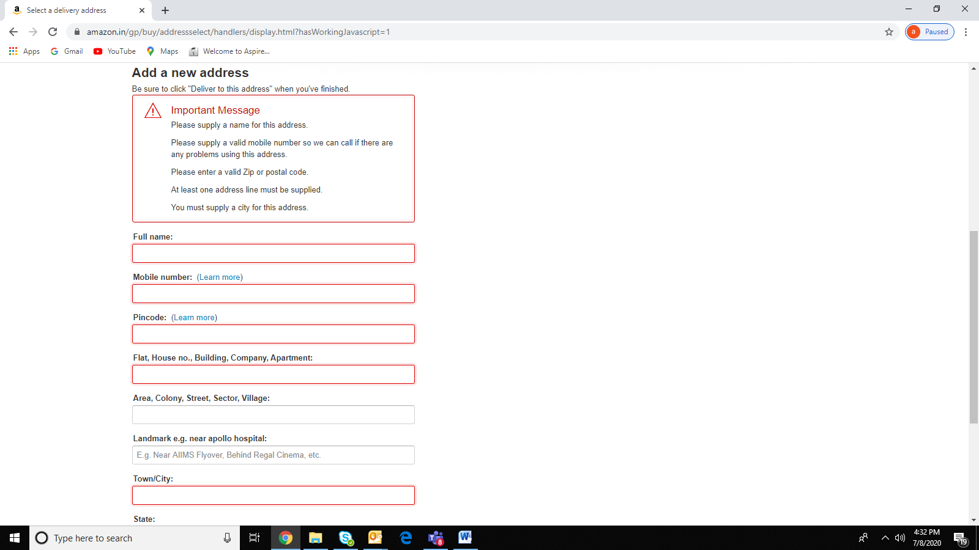

1. Payment Details
   1. The user should be given options with various modes of payment.
   2. Online payment through credit/debit cards, via net or mobile banking or cash on delivery, out of which the user should choose one.
   3. The chose mode of transaction should be carried therefore by proper verification and authentication of bank details.

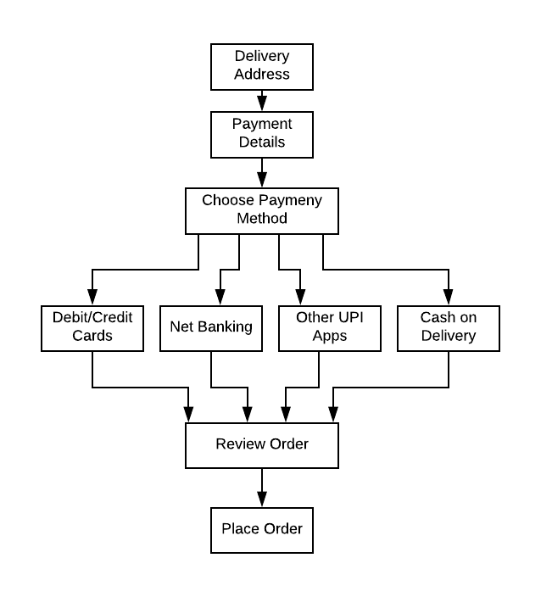

1. The user should review before placing the order and complete the transaction.

**Requirements: Fresher**

Follow proper naming conventions.

Create package shop.

Use OOPs concepts wherever applicable

Create separate class to store user details and shop details.

Encapsulate the class variables using getter and setter method.

Use constructors wherever applicable for initializing the class variables.

Implement inheritance and polymorphism wherever required.

Implement interface or abstract class wherever applicable.

Implement static modifier in appropriate place.

**Exception handling**

1. Implement exception handling mechanism for the above application.
2. Create and use your own custom exceptions:

**ProdcuctNotFoundException**

**InvalidUserNameAndPasswordException**

**ProductOutOfStockException**

1. **Raise the user defined or custom exception when the user selects the non-existent product and invalid username and password and handle it.**
2. If someone tries to select a non-existent product, an appropriate exception should be thrown.
3. A non-account holder should view only the products but the user should sign in with a valid user name and password to check out the product in the cart and buy the products.
4. If the user tries to buy the product which is out of stock, then a stock out exception should be thrown and handle it appropriately.
5. **Handle all possible exception wherever required and follow the exception handling hierarchy.**

**Collections Framework**

1. Develop an online shopping application where the user should do view, navigate, select the products, add to cart if he wishes to buy, edit the products list in the cart and check out for payment.
2. It should remember the products added to the cart and display it to the user.
3. Implement appropriate collection interface to store the products in the cart.
4. Use list interface to get history and display the details.
5. Use appropriate interface to generate the invoice bill of the purchase.

**Database Connection**

Connect the Java online shopping application with MySql database using JDBC driver. Perform all the operations from the front end application and interact with the back end database.